9.45: From Eq. (9.17), 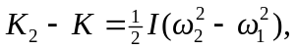 and solving for I,

